**Lambda Expression Assignment**

Q1. Write an application to perform basic arithmetic operations like add, subtract, multiply & divide. You need to define a functional interface first.

Description:-

Define Functional Interface and write a program to perform arithmetic operations like add, subtract, multiply and divide using functional interface.

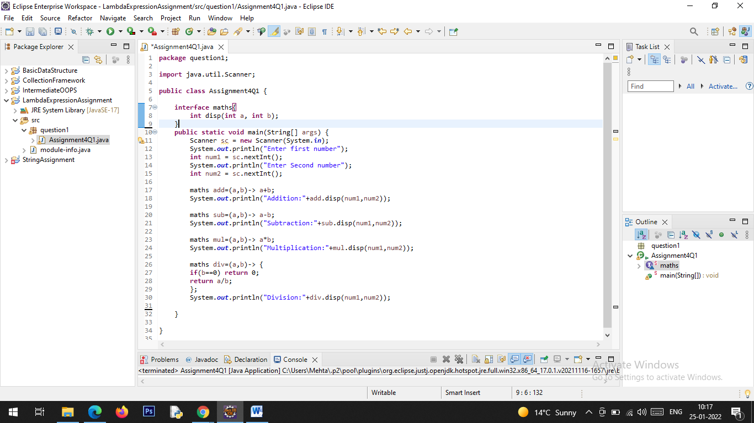

**Output:**

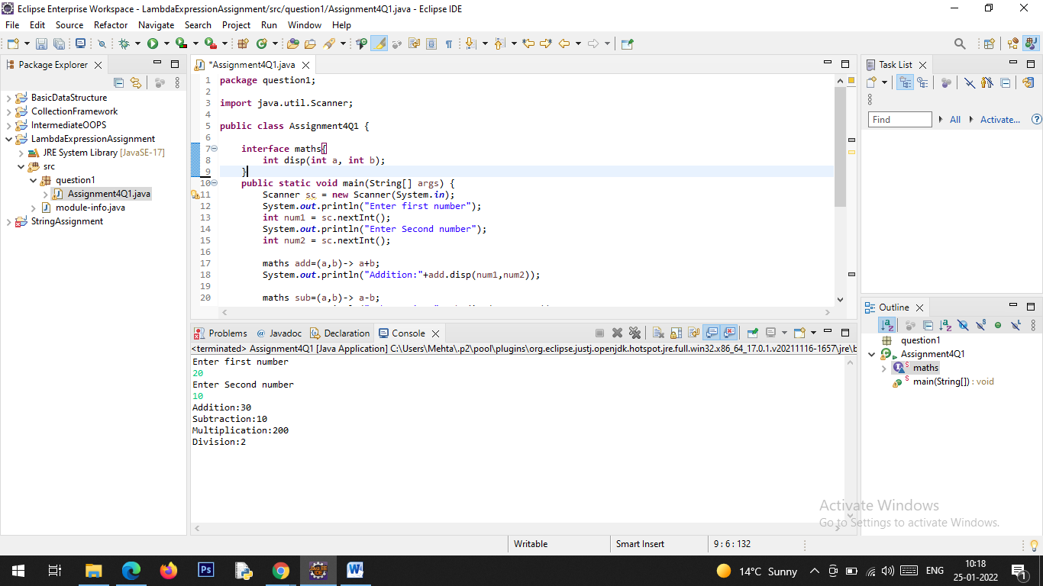

Q2. Write an application using lambda expressions to print Orders having 2 criteria implemented: 1) order price more than 10000 2) order status is ACCEPTED or COMPLETED.

Description:

Write a program in such a way that it has a method which returns the list of orders satisfying the 2 conditions mentioned in the question.

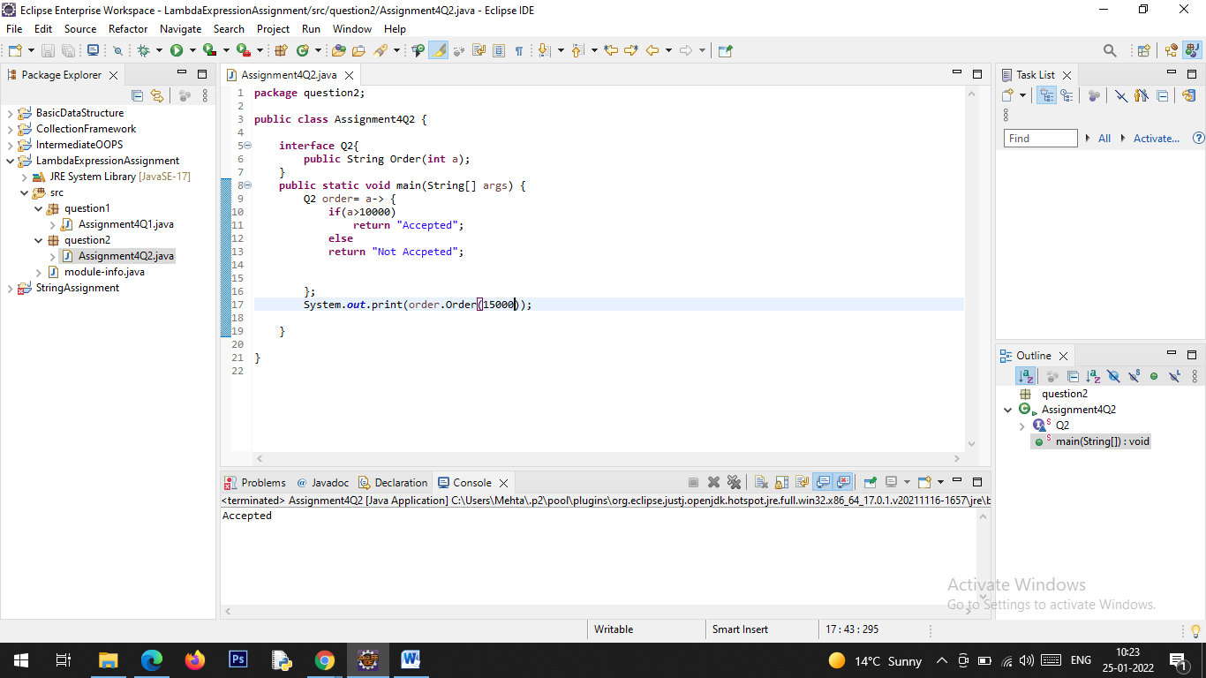

**Output:**

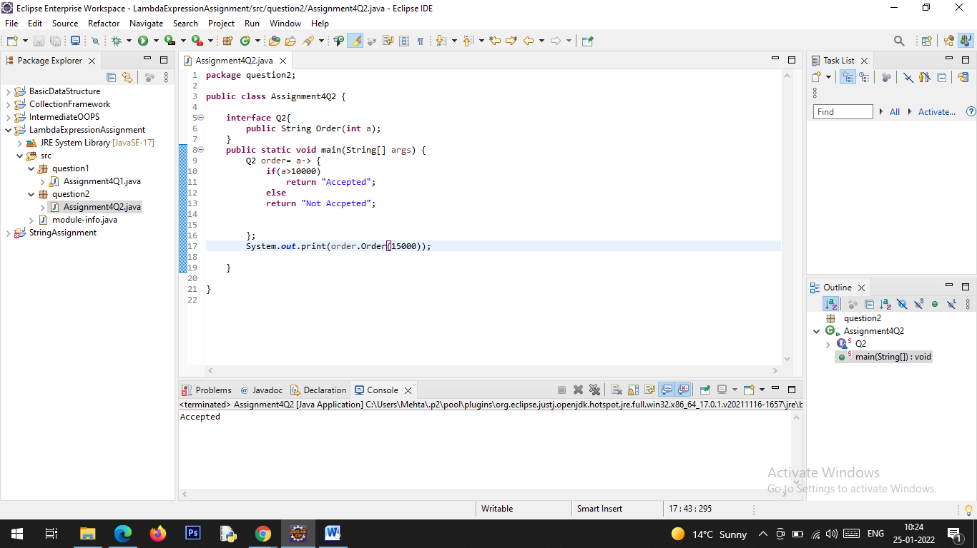

Q3. Use the functional interfaces Supplier, Consumer, Predicate & Function to invoke built-in methods from Java API.

Description:

Write a program using the Java API’s mentioned in the question.

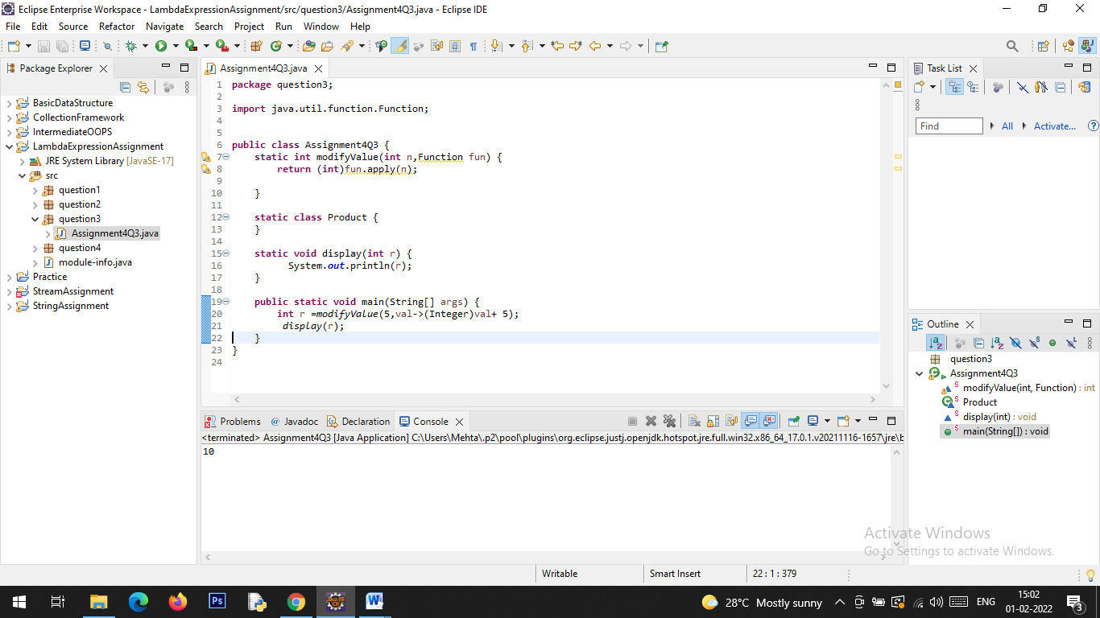

**Output:**

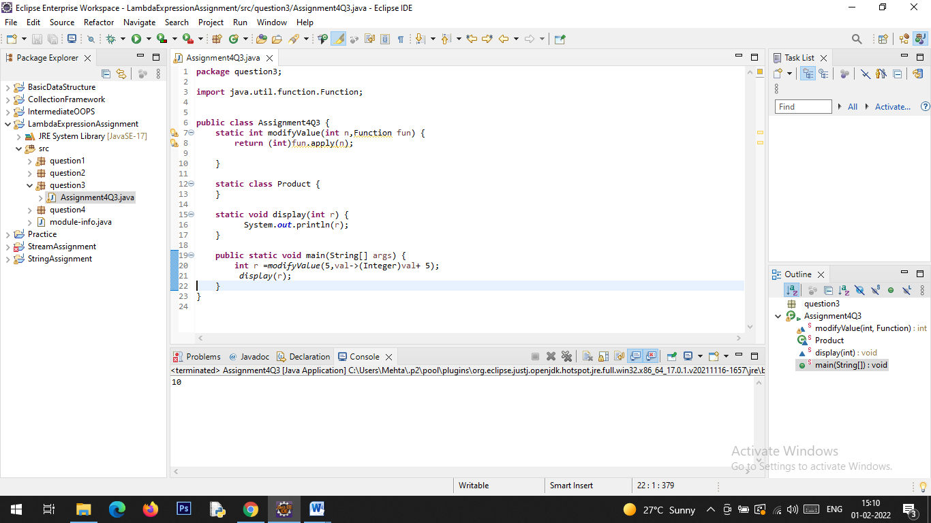

Q4. Remove the words that have odd lengths from the list. HINT: Use one of the new methods from JDK 8. Use removeIf() method from Collection interface.

Description:-

Write a program using java 8 features which can remove the odd length words from the list.

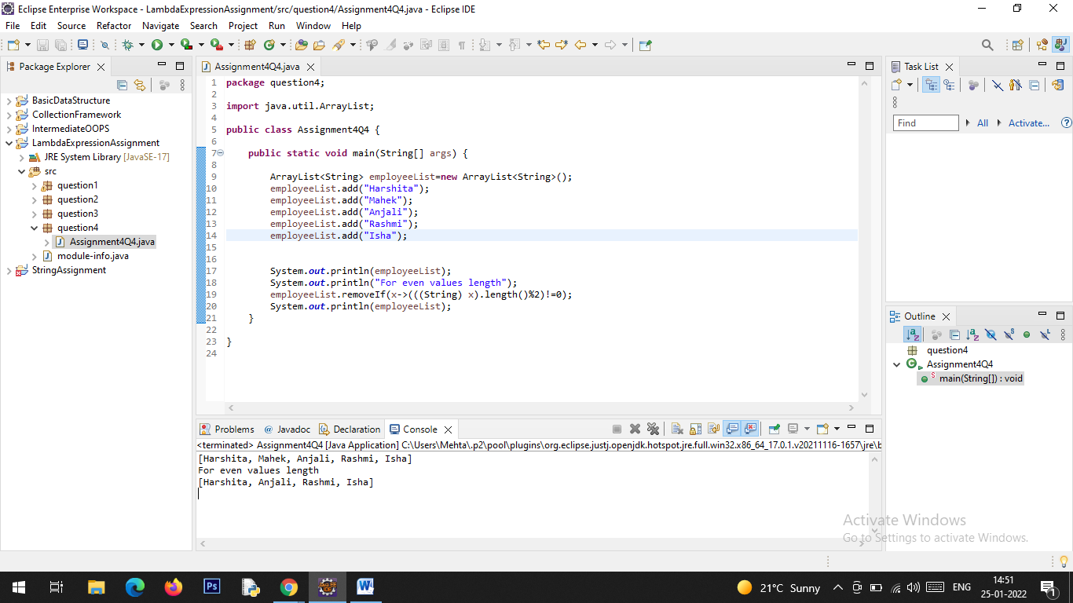

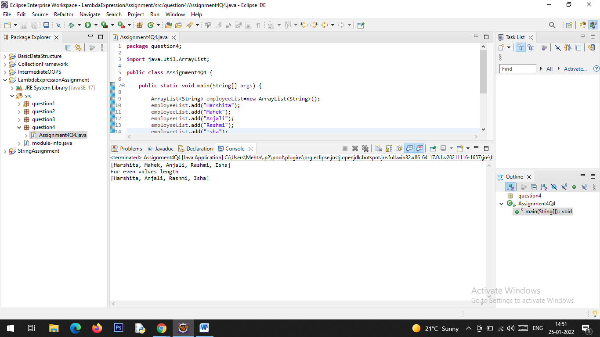

Q5. Create a string that consists of the first letter of each word in the list of Strings provided. HINT: Use Consumer interface & a String Builder to construct the result.

Description:

Write a java program using StringBuilder and Consumer interface which will return a string. The returned string should consistes of the first let of each word in the list of words.

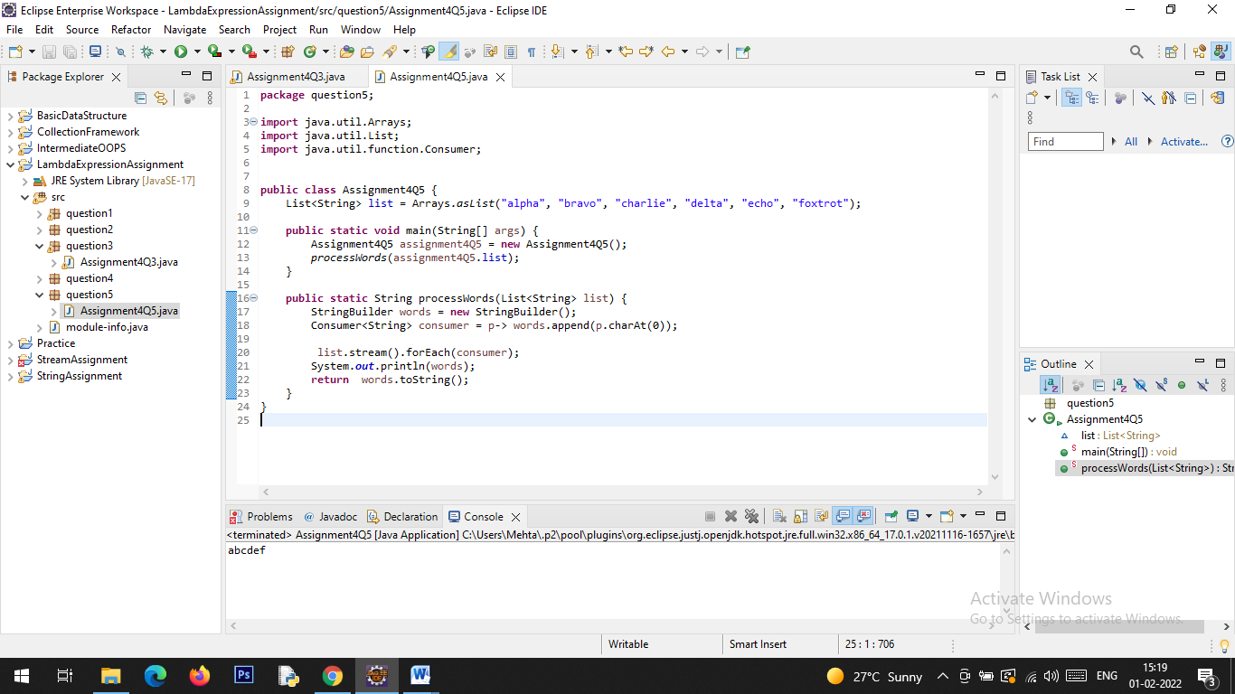

**Output:**

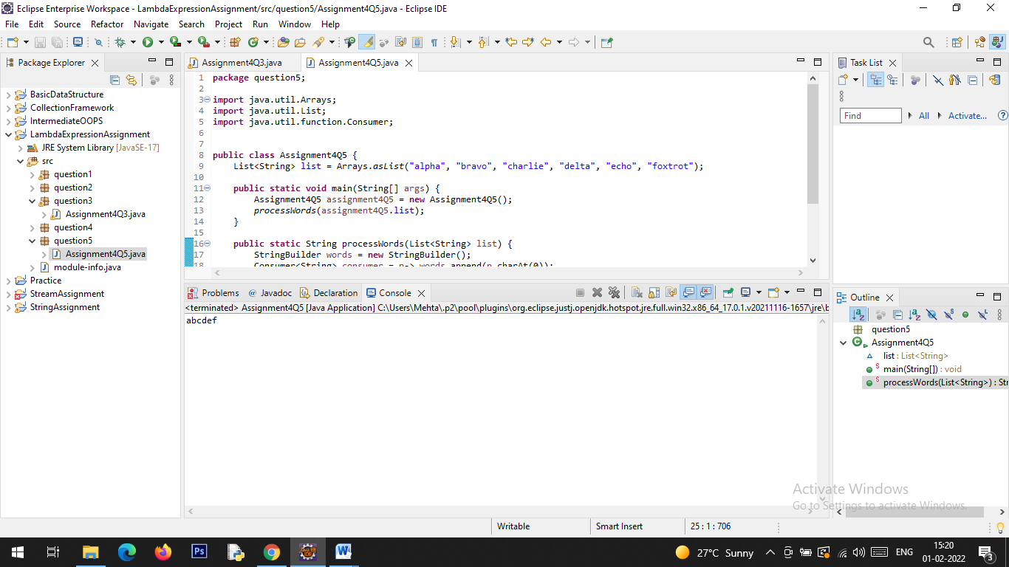

Q6. Replace every word in the list with its upper case equivalent. Use replaceAll() method & Unary Operator interface.

Using replaceAll() method and Unary Operator interface write a java program which replaces evry word in the list with its upper case equivalent**.**

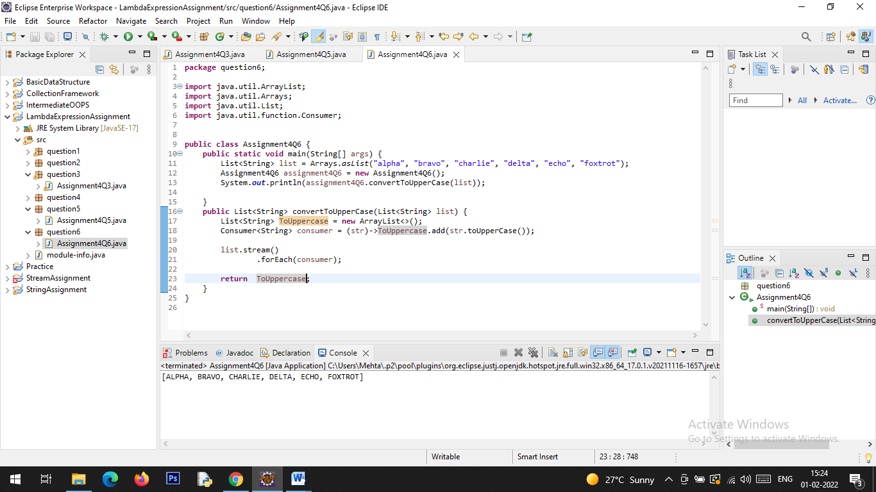

**Output:**

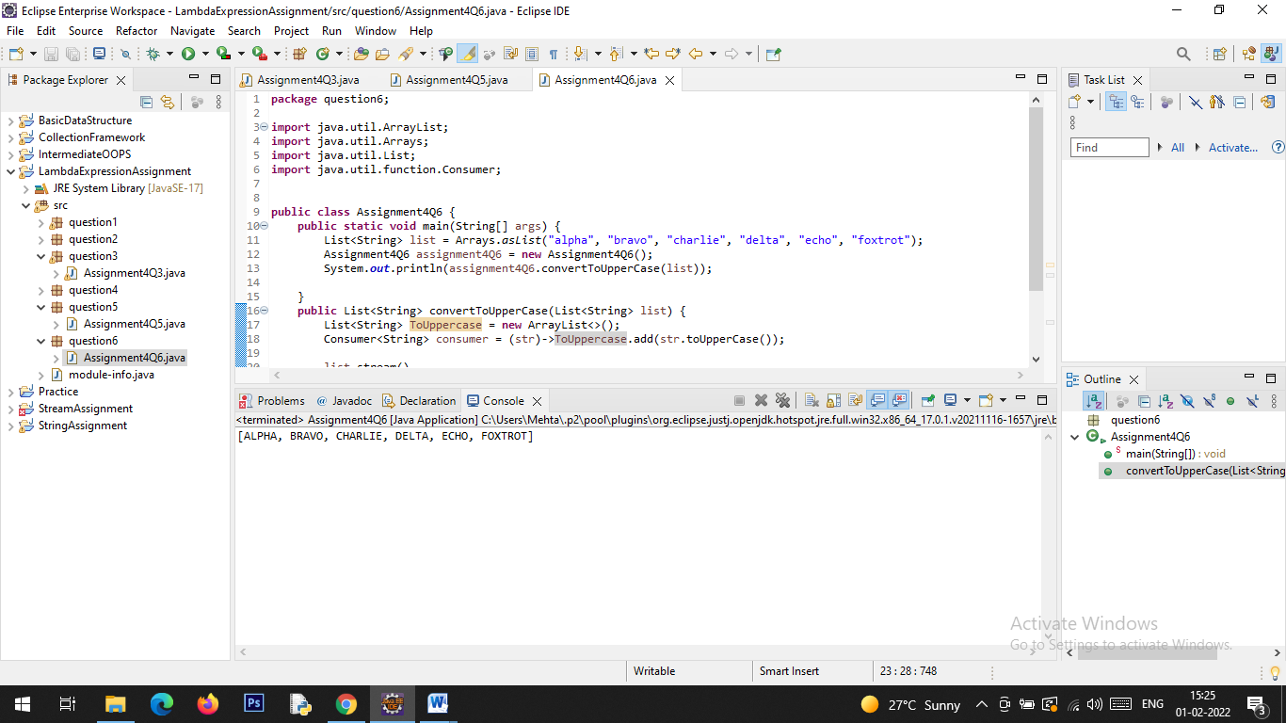

Q7.Convert every key-value pair of the map into a string and append them all into a single string, in iteration order. HINT: Use Map.entrySet() method & a StringBuilder to construct the result String.

Description:-

Write a java program using Map.entrySet() method & a StringBuilder which will return a string by appending all the key value pairs of a map into a single string ,in insertion order.

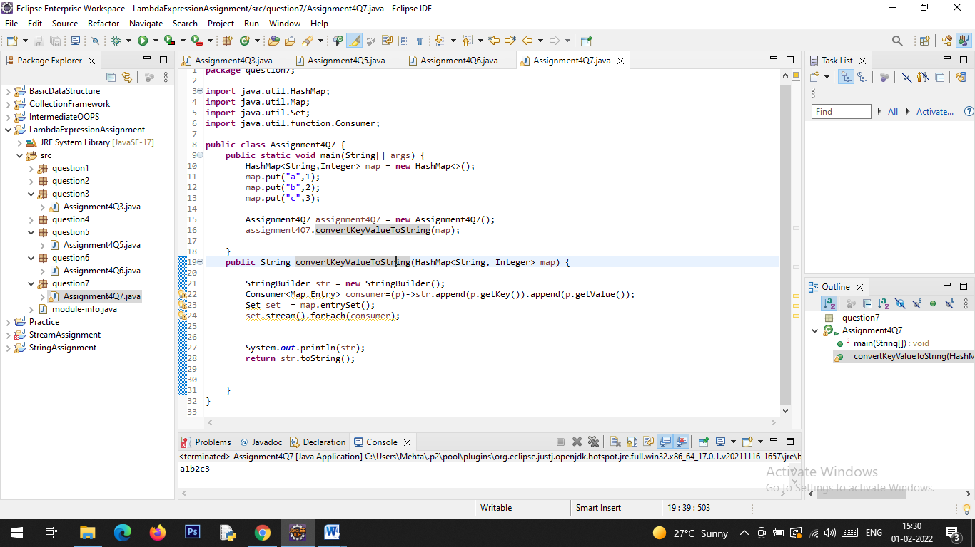

**Output:**

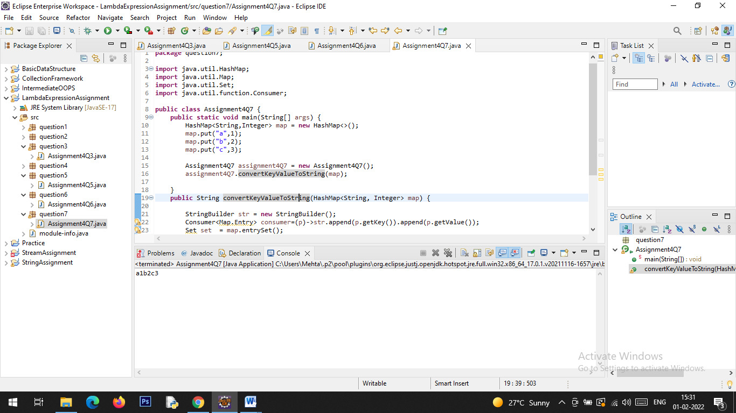

Q8. Create a new thread that prints the numbers from the list. Use class Thread & interface Consumer.

Description:-

Write a java program which will print the list of number using Thread and interface Consumer.

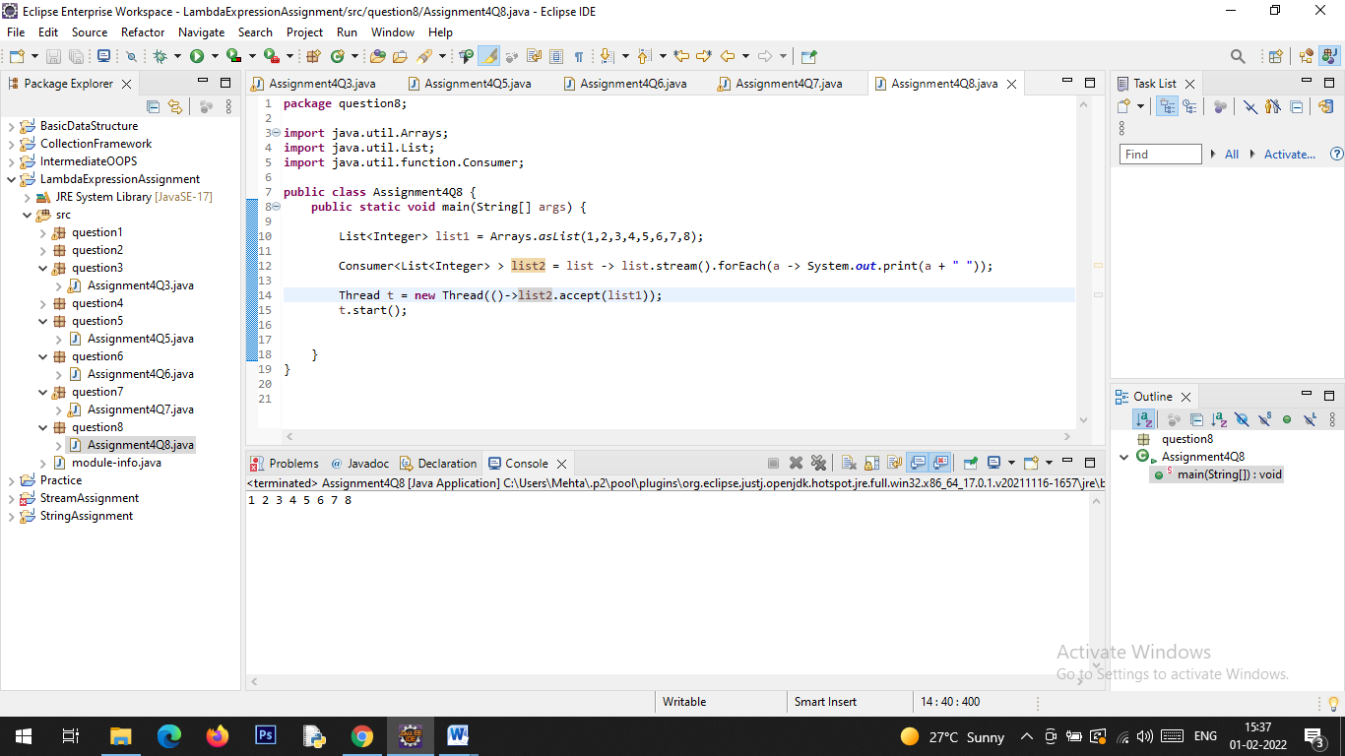

**Output:**

